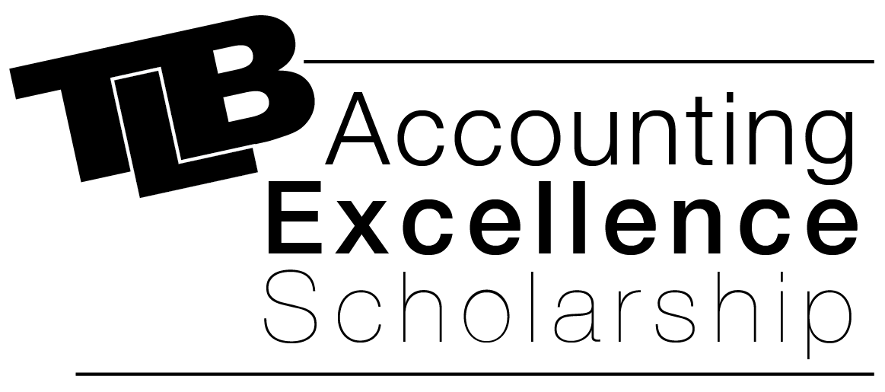

T. L. Baker & Co., LLP provides a $500.00 scholarship for the college education of a graduating senior who has a particular interest in pursuing a degree in accounting and/or business.

To qualify a student must:

- Be a graduating senior
- Cumulative GPA of at least 3.0 (or its equivalent)
- Attach a one-page (or less) essay on why you wish to pursue a career in the accounting field
- Return completed application, transcript and essay to counseling office by no later than Friday, April 13th
- Agree to picture and news release to local media and all TLB social media accounts upon receipt of the scholarship award

Scholarship Application

Applicant Information
Full Name: |  | Date:

Parents
Names:

Address:
 | Street Address | Apartment/Unit #

 | City | State | ZIP Code

Phone: |  | Email

Accounting Career Goal:

Education
High School: |  | Current GPA:

Address:

Post-Secondary School
Please list the name and address of the post-secondary school you plan to attend in 2018-2019.
College:

Address:

School Activities
Please list and describe any extracurricular activities you were involved in, the year(s) participated and any honors received below.

Volunteer Service
Please list and describe any service to school, church, clubs, and/or community below. Please give years involved.

Essay
Please provide a one-page (or less) essay detailing why you would like to pursue a career in Accounting and/or Business. Include in your response your professional goals and how the T.L. Baker & Co. Scholarship will assist you in achieving those goals.

Disclaimer and Signature
I certify that my answers are true and complete to the best of my knowledge.
Signature: |  | Date:

